Reporting on Section 6
Community and Town Councils

Environment (Wales) Act 2016 Part 1 – Section 6
The Biodiversity and Resilience of Ecosystems Duty

The Biodiversity and Resilience of Ecosystems Duty
Report 2025
Name of Community or Town Council: | Bishton Community Council
Group:
Introduction and Context
Bishton Community Council (BCC) lies, in the Llanwern electoral district (ward) and encompasses the villages of Wilcrick, Underwood and Bishton with approximately 2000 residents.
Wilcrick.
‘Wilcrick’ is a welsh name which translates as ‘bare hill’ – the hill referred to is now tree clad and is the location of an iron age fort from where extensive views down the Severn Estuary are afforded; essential for an early warning of Irish invasion up the estuary. The tiny church of St Mary the Virgin, is located on the lower slope of the hill and once served a much larger settlement abandoned during the middle ages in common with several other locations in the local area.
The church has its points of interest and its curiosities – it is necessary to present the key to the south door ‘upside-down’ to gain entry! The church was entirely rebuilt in 1860, but it retains a vase like 12th century font, a tablet to an 18thcentury rector who ministered here for an incredible 57 years, late 17th or early 18th century altar rails and a bell of 1726 cast by the Evans foundry of Chepstow.
The Victorian glass within the east window features the four evangelists. Also look out for a stone seemingly randomly located within the east wall, bearing the date 1621, as well as the pedestal sundial. The church has recently been redecorated and is much loved by a small, but committed congregation.
Bishton.
Bishton or Bishopston (Welsh: Llangadwaladr Trefesgob or simply Trefesgob) is a small rural community located on the Gwent levels in the east of the city of Newport, South Wales. The name is said to derive from "Bishop's Town", as the village has been alleged to the sometime home of the Bishops of Llandaff. Owain Glyndŵr destroyed the palaces at Bishton and Llandaff, from which time the episcopal palace was moved to Mathern. Bishop John Pascall died here of the plague in 1361.
Bishton Saint Cadwaladr Church is the only church is the country dedicated to Cadwaladr, although it is possible that St Mary's Church, Magor also was originally dedicated to him. Cadwaladr was the last Welsh ruler to call himself King of Britain and he earned the title "blessed" for his peaceful disposition. He died of the plague in 664 AD.
The original decorated and perpendicular church was damaged in 1760 when part of the tower collapsed into the nave. Considerable rebuilding and restoration was required. The north porch is a 19th-century addition. Whilst some of the lancet windows are original, the east window, the west tower window and the two south windows to the nave are Victorian insertions. The origins of the chancel arch are unclear and it seems to have been reconstructed from earlier stonework, incorporating medieval corbel heads of a monk, a nun, a man and a woman. The stoup is located near the north door. The font is a late medieval piece. The stained glass to the east window, which depicts Christ as the Light of the World and as the Good Shepherd, dates from about 1915. Use of the Welsh language in services continued at the church until 1828.
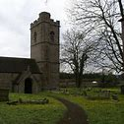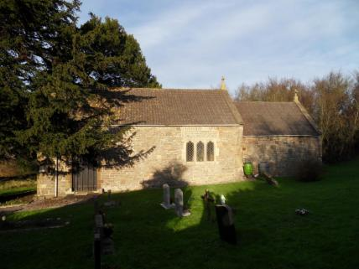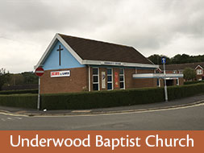
St Cadwaladr, Bishton St Mary the Virgin, Wilcrick Baptist Church, Underwood
Underwood.
The Underwood Estate was originally developed from the former World War II Prisoner of War camp after the end of the war. A few surviving examples of the former PoW huts were still visible until the early 1990s when they were demolished. The original huts stood as early community buildings. In the early 1980s several huts and a water tower were also visible on the now Waltwood Park Drive area, this area belonged to the General Post Office and was used to house old telecommunications equipment until it was sold and demolished by British Telecom who took over the site when BT was privatised in the early 1980s. The land was subsequently sold to Westbury homes who built the Waltwood Park Drive Development of around 220 houses on the land.
The estate is situated in a natural land formation within the falls of a wooded area on the south and north side and a small drainage ditch or reen called "Monks Ditch" on the northern side of the development. Built in three phases, with the Waltwood Park Development being the last of the three phases.
Many people believe that the Underwood Estate was created for the local steelworks at Llanwern, as it was constructed at the same time as the Richard Thomas and Baldwins "Spencer Works" was being built. This has some truth, as originally people moved into the huts after the war. However the local council at the time, Magor and St Mellons Rural District Council, created the housing estate with post-war initiatives for more housing, hence why the second phase of the housing development consists of rapid construction poured concrete houses which are very sturdy in construction and much stronger than traditional bricks-and-mortar houses.
Bishton Community Council (BCC) provide a range of services to the communities which impact on how we view our environment as well as on local biodiversity. These include:
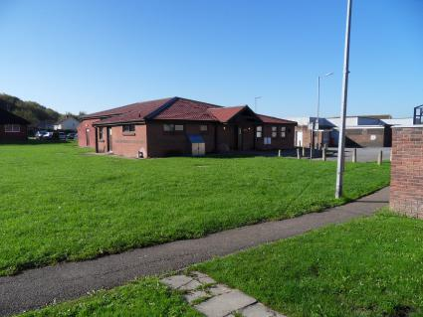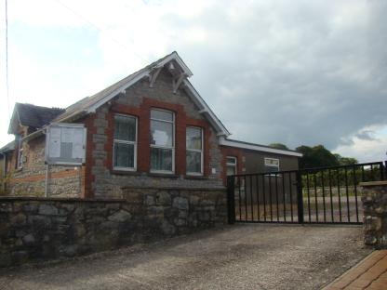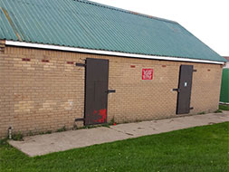
Underwood Community Centre Bishton Village Hall Football Changing Rooms
- Facilities. BCC have responsibility for a number of green spaces including a play park a sports field and a Cycle Speedway for community use. We also own and maintain a Community Centre in Underwood and a Village Hall in Bishton The local Underwood FC football team changing rooms are maintained by BCC but the team is organised and run by volunteers who are local residents. The football field is secured on a long lease to BCC from Newport City Council. The Underwood Flyers cycle speedway is located at the south end of Underwood Village and is organised, financed and run by volunteers who are also local residents. There are also 3 churches within the BCC area, 2 of which have graveyards, and an allotment site with 40 allotments for use by local residents.
Biodiversity
- Allotments. BCC provide 40 allotments for local residents to promote a ‘grow your own’ culture. This is not only beneficial as a food source to those that use them but also helps to keep those who are retired fit and occupied, as well as providing an educational opportunity to allotment holders with young children and the local primary school so they can learn how vegetables are grown and hopefully develop the taste for home grown produce and, perhaps, fan an interest for there own garden when they are older. The allotments are wedged between the M4 motorway on one side and surrounded by trees and brush on the other three, thus providing bees, butterflies and other insects with nourishment for most of the year.
- Most allotments are quite large (10m x 30m) which are too much for some people to work. We have ideas to split some plots which become vacant and equip them with raised beds before rehiring. These are intended for those residents who have difficulty bending but still have an interest in gardening and ‘growing their own’.
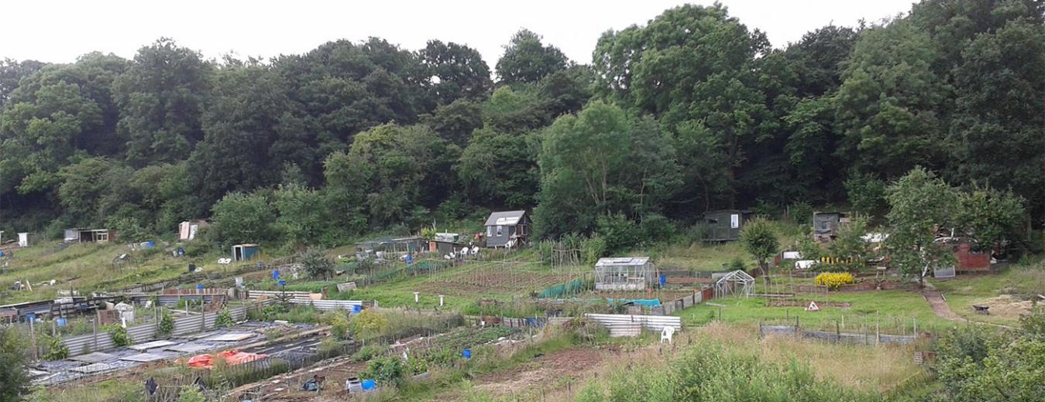
Interest has recently been expressed to keep Bee Hives on the allotments. Although we generally support the idea advice is currently being sought regarding council & bee keeper responsibilities prior to permission being granted.
- Planters. We have 21 planters and a small memorial garden located around the communities which are maintained by a small number of volunteers. The planters not only fulfil the goal of increasing the optical impression of a community that cares about its environment but also provides vital nourishment for a wide variety of insects that we also need for pollinating other fruit bearing plants in our own gardens. Plants in the planters blossom at different months throughout the year thus providing a continuous valuable food source for insects over a longer period.
- Community litter picks – the council organises regular community litter picks in and between the 3 villages
Action Report 2023 - 2025
NRAP  Objective | Action carried out to… |  | Monitored by:
1 | -embed biodiversity into decision making & procurement | Our grounds maintenance contract with NCC for 25/26 will be reviewed and amended to reflect best practice in promoting bio-diversity.  The council intends to review its BAP and republish and agree an updated version at its annual meeting in May 2026. | Council
1 | -raise awareness of biodiversity & its importance | The council was successful in gaining two green flag awards in 2025 , following on from an award gained in 2024 – details of the awards were published on the council website.  The councils annual Best in Bloom competition was held in Summer 2025  This years competition included a new award for Best street garden to recognise efforts to improve biodiversity on local streets as well as gardens | Chairman, Council and Clerk
2 | -safeguard principal species and habitats | Actions to be considered as part of development of updated BAP | Council
3 | -restore & create habitats and resilient ecological networks | Actions to be considered as part of development of updated BAP | Council
4 | -tackle negative factors: for e.g. reduce pollution, use nature based solutions, address invasive species | Actions to be considered as part of development of updated BAP  Lobbied for clean ups of local brook | Council
5 | -use improve and share evidence | Actions to be considered as part of development of updated BAP | Council
6 | -support capacity and/or other organisations | Actions to be considered as part of development of updated BAP | Council

Review of S6 duty actions for 2023-2025
What has worked well? Local participation in litter picking and improving local spaces

What have the barriers been? Lack of capacity amongst councillors and council team to undertake more pro-active bio-diversity protective action
What will you change? Review and revise the council BAP and report on it quarterly to full council
How and when will the s6 duty be monitored and the s6 plan reviewed? As above – quarterly at full council

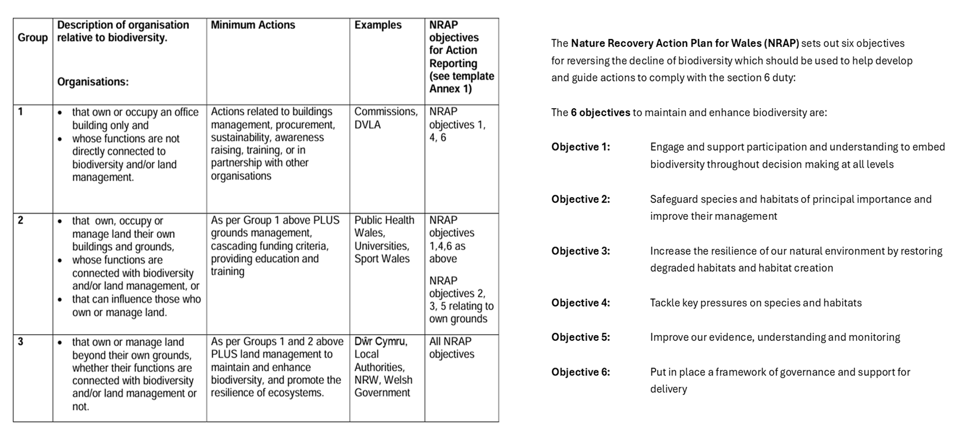
Back

Adrodd ar Adran 6
Cynghorau Tref a Chynghorau Cymuned

Deddf yr Amgylchedd (Cymru) 2016 Rhan 1 – Adran 6
Y Ddyletswydd Bioamrywiaeth a Chydnerthedd Ecosystemau

Adroddiad 2025
Ddyletswydd Bioamrywiaeth a Chydnerthedd Ecosystemau

Enw y Cyngor Tref neu Gymuned:
Grŵp:
Cyflwyniad a'r Cyd-destun
- Disgrifiad byr o'r Cyngor, ei swyddogaethau a'r cyd-destun o ran
- sut y gallai helpu bioamrywiaeth (trwy ei swyddogaethau rheoli tir, cyllid grant, gweithgareddau addysgol e.e.)

- graddfa ofodol a lle (e.e. faint o dir mae'n ei gynnwys, poblogaeth, praesept?)

- cyflawni gwasanaethau i'r cyhoedd (e.e. a yw'n destun Ddeddf Llesiant Cenedlaethau'r Dyfodol?)
Adroddiad Gweithredu 2023 - 2025
Amcan NRAP | Camau gweithredu i... |  |  | Wedi eu monitro gan:
1 | -cynnwys bioamrywiaeth o fewn llunio penderfyniadau a chaffael
1 | -codi ymwybyddiaeth o fioamrywiaeth a'i bwysigrwydd
2 | -diogelu prif rywogaethau a chynefinoedd
3 | -adfer & chreu cynefinoedd a rhwydweithiau ecolegol cydnerth
4 | -mynd i'r afael ag elfennau negyddol: lleihau llygredd e.e. defnyddio atebion yn seiliedig ar natur, mynd i'r afael â rhywogaethau goresgynnol
5 | -defnyddio gwella a rhannu tystiolaeth
6 | -cefnogi capasiti ac/neu sefydliadau eraill

Arolwg o ddyletswydd Adran 6 2023 - 2025
Beth sydd wedi gweithio'n dda?

Beth fu'r rhwystrau?
Beth fyddwch yn ei newid?
Sut a phryd fydd y ddyletswydd Adran 6 yn cael ei monitro a'r cynllun Adran 6 wedi'i adolygu?

Nôl
